What is a data flow diagram?

A data flow diagram (DFD) maps out the flow of information for any process or system. It uses defined symbols like rectangles, circles and arrows, plus short text labels, to show data inputs, outputs, storage points and the routes between each destination. Data flowcharts can range from simple, even hand-drawn process overviews, to in-depth, multi-level DFDs that dig progressively deeper into how the data is handled. Often it is a preliminary step used to create an overview of the system that can later be elaborated.

Data flow diagram for Our Project?

* Registration Page :The New User Registration page where the User inputs his requisites and also takes his picture for face-recognition.
* Home Page : The page where from where the User can start his/her work and also his records are displayed over there. It’s the page from where the User can be redirected to any page.
* Help Index : Help Index is a page where the user can connect to the software controller department for any problem occurred.

Registration Page Data Flow Diagram

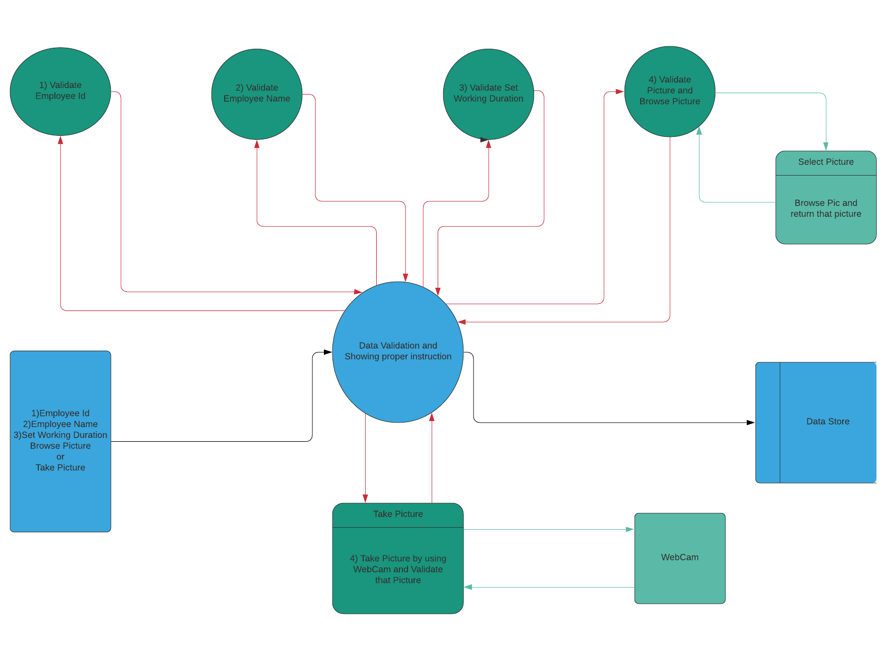

Home Page Data Flow Diagram

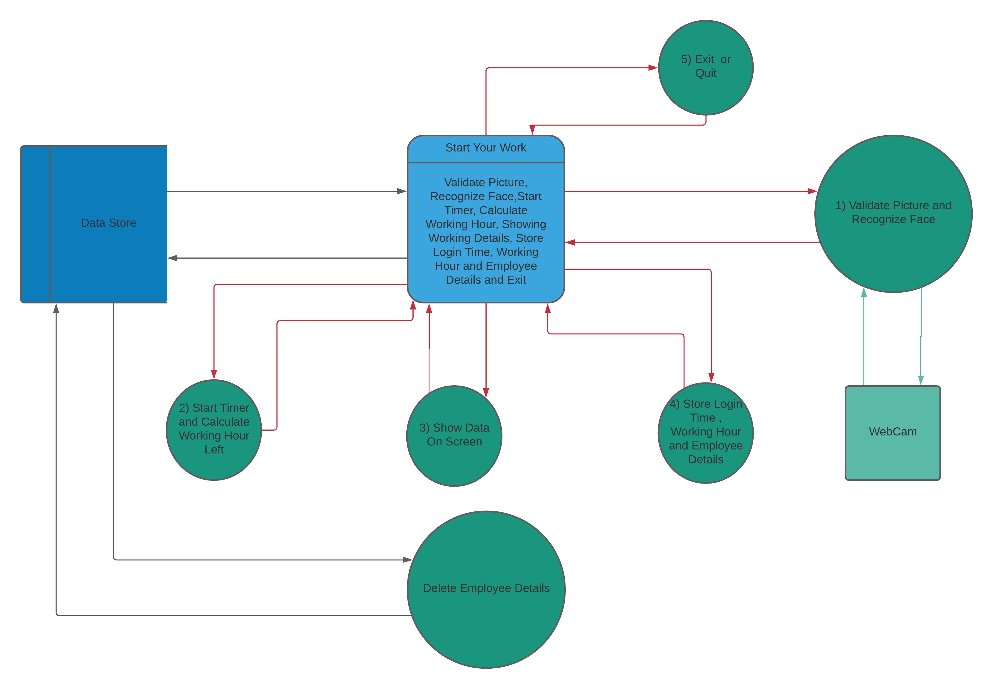

Help Index Data Flow Diagram

